**CONFIDENTIAL**

**Project name: ONLINE STUDENT ATTENDANCE SYSTEM**

**Class Design Specification**

|  |  |
| --- | --- |
|  |  |
|  |  |
|  |  |
|  |  |
|  |  |

**DOCUMENT VERSION HISTORY**

|  |  |  |
| --- | --- | --- |
| **Document Version** | **Date Issued** | **Comments** |
| 1.0 | 28-06-2018 | First version of the Web Portal |
|  |  |  |
|  |  |  |
|  |  |  |
|  |  |  |
|  |  |  |
|  |  |  |
|  |  |  |

# **Table of Contents**

Table of Contents 2

Class Design

1 Introduction 3

2 Conventions followed 3

3 Class Diagrams 4

# **Introduction**

The class diagram is the main building block of [object oriented](http://en.wikipedia.org/wiki/Object_oriented) modelling. It is used both for general [conceptual modelling](http://en.wikipedia.org/wiki/Conceptual_model) of the systematics of the application, and for detailed modelling translating the models into [programming code](http://en.wikipedia.org/wiki/Programming_code). Class diagrams can also be used for [data modeling](http://en.wikipedia.org/wiki/Data_modeling). The classes in a class diagram represent both the main objects and or interactions in the application and the objects to be programmed. In the class diagram these classes are represented with boxes which contain three parts:

A class with three sections:

* The upper part holds the name of the class
* The middle part contains the attributes of the class
* The bottom part gives the methods or operations the class can take or undertake

# **Conventions followed**

Hungarian Convention

# **Class Diagrams**

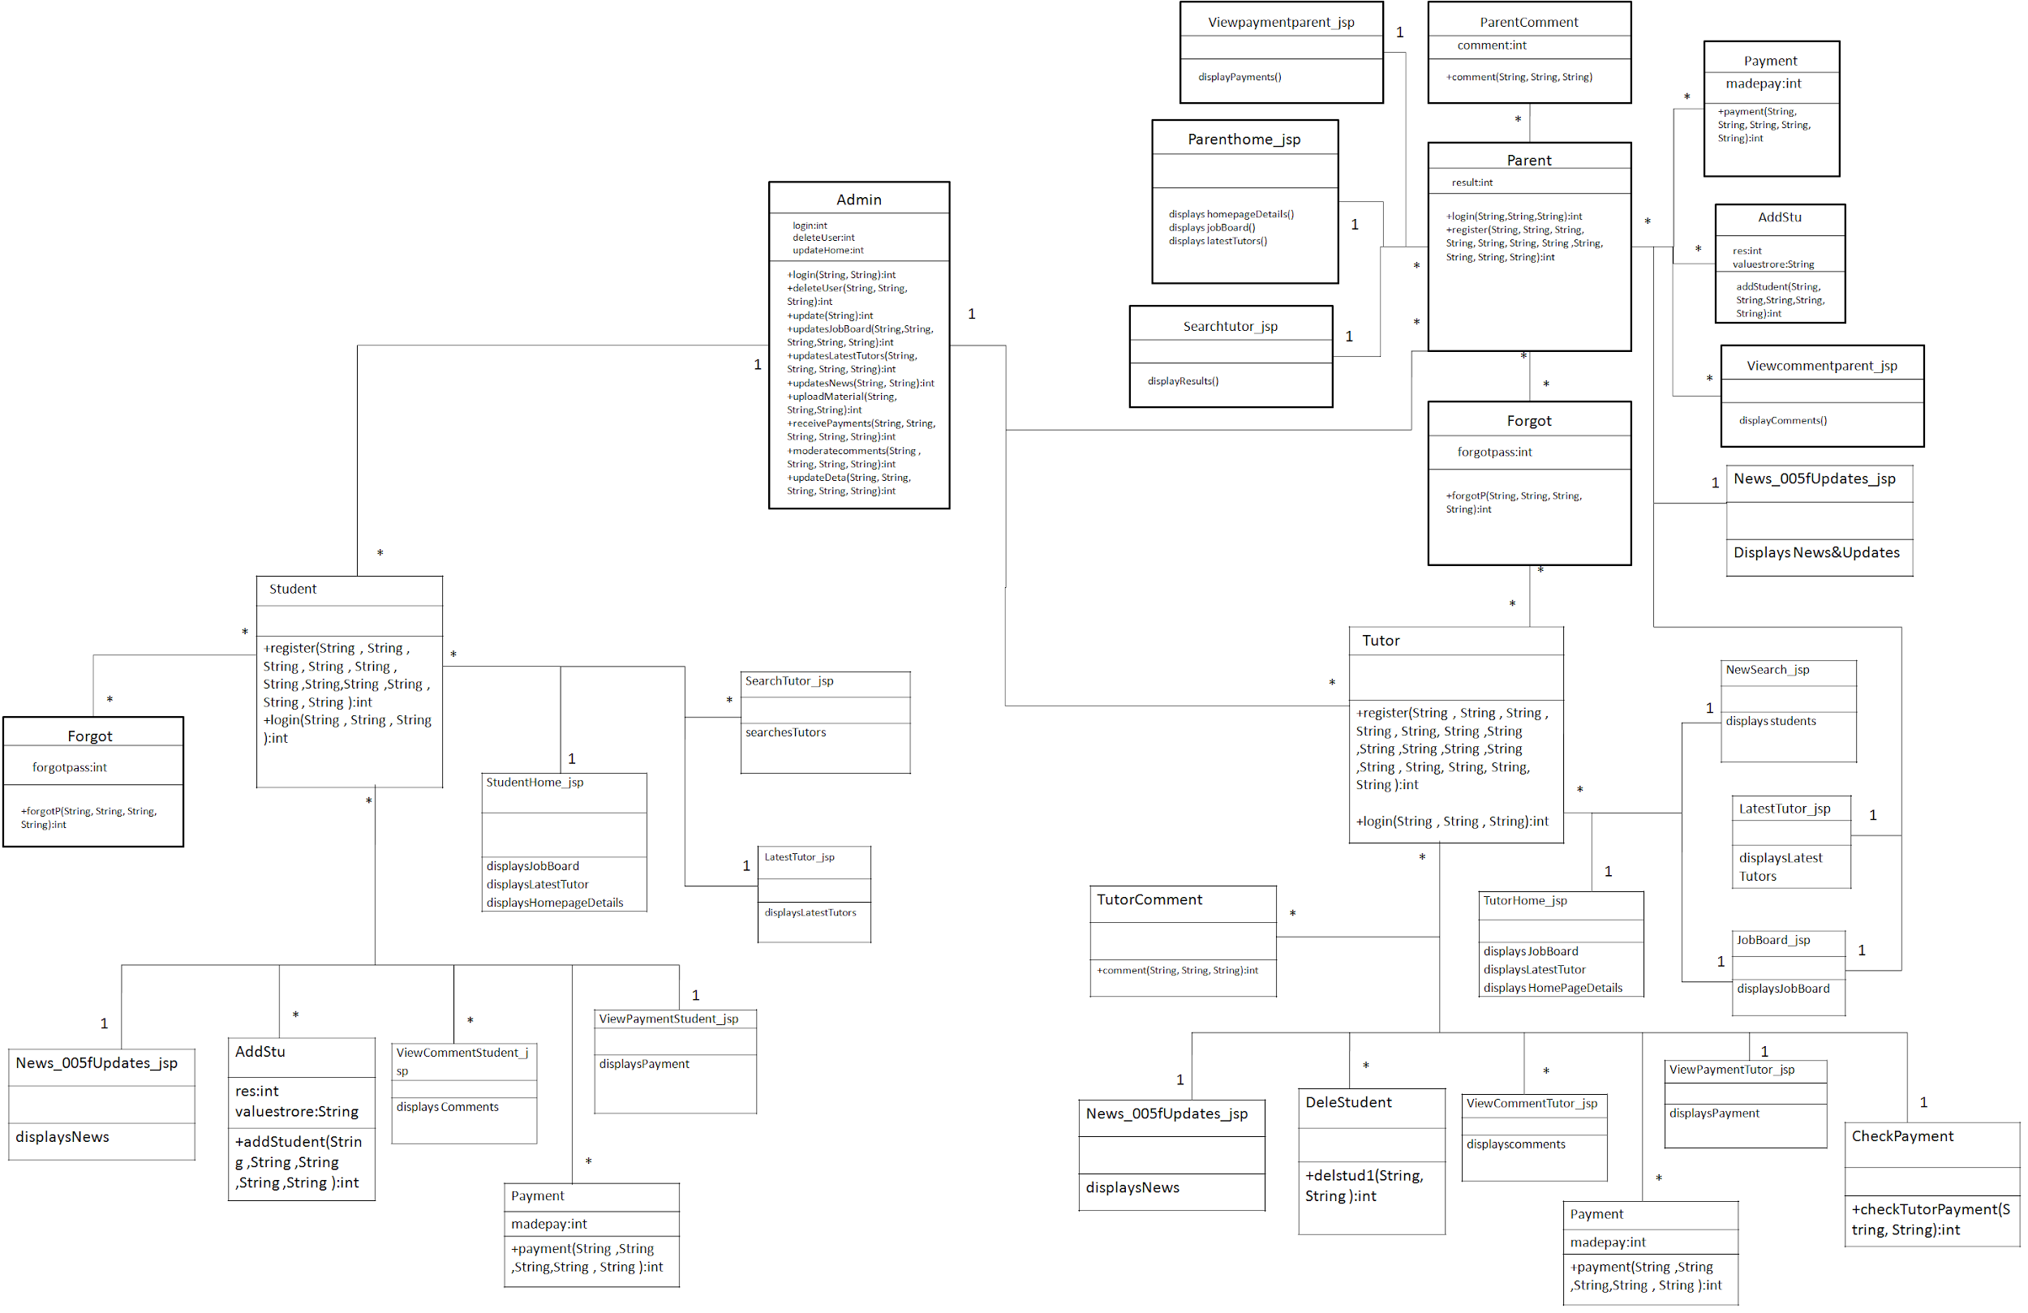

# **Classes**

## **Admin**

**Class Description :**

**The Administrator class holds those attributes and functions which may be used for the functioning of the system. The administrator manages faculty, parent and student. The administrator uploads online study materials and sends email notices on behalf of the departments**

**Methods**

|  |  |  |  |
| --- | --- | --- | --- |
|  | **Function** | **OutPut Parameters** | **Description** |
| **1** | **deleteUser(String, String, String)** | **int** | This function deletes the existing user from the database |
| **2** | **login(String, String)** | int | checks for the authentic username and password and provides the login |
| **3** | **updateData(String, String, String, String, String)** | int | the administrator make changes in the user details, qualifications, etc |
| **4** | **uploadMaterials(String, String, String)** | int | the administrator uploads materials which can be accessed online or downloaded and can be used by user for learning |
| **6** | **update(String)** | int | the administrator keeps the website updated by updating the home page details |

## **Student**

**Class Description :**

**The Student class contains the attributes and related functionality for the students**

**Methods**

|  |  |  |  |
| --- | --- | --- | --- |
|  | **Function** | **OutPut Parameters** | **Description** |
| **1** | **register(String, String, String, String, String, String, String, String, String, String, String)** | int | registers the new student in the portal |
| **2** | **login(String, String,String)** | int | authenticates the student to login |

### **Forgot**

**Class Description :**

**The Forgot class enables the student user to reset his username and password if he/she has forgot it.**

**Methods**

|  |  |  |  |
| --- | --- | --- | --- |
|  | **Function** | **OutPut Parameters** | **Description** |
| **1** | **forgot(String, String, String, String)** | int | This function enables the student to reset his password.  updates the username, password to the new one |

### **StudentHome_jsp**

**Class Description :**

**This class holds the business logic to display the values stored in the database.**

**Methods**

|  |  |  |  |
| --- | --- | --- | --- |
|  | **Function** | **OutPut Parameters** | **Description** |
| **1** | **displaysNotices** | displays the important notices |  |
| **2** | **displaysAssignment** | displays assignments uploaded by the faculty |  |
| **3** | **displaysHomePageDetails** | displays the homepage details |  |

### **AddStu**

**Class Description :**

**This class holds the business logic to display the values stored in the database.**

**Methods**

|  |  |  |  |
| --- | --- | --- | --- |
|  | **Function** | **OutPut Parameters** | **Description** |
| **1** | **addStudent(String, String, String, String, String)** | int | enables the student to get added in the batch of the particular tutor |

## **Parent**

**Class Description :**

**The Parent class contains the attributes and related functionality for the parent**

**Methods**

|  |  |  |  |
| --- | --- | --- | --- |
|  | **Function** | **OutPut Parameters** | **Description** |
| **1** | **register(String, String, String, String, String, String, String, String, String, String, String)** | int | registers the new parent in the portal |
| **2** | **login(String, String,String)** | int | authenticates the parent to login |

### **Forgot**

**Class Description :**

**The Forgot class enables the parent user to reset his username and password if he/she has forgot it.**

**Methods**

|  |  |  |  |
| --- | --- | --- | --- |
|  | **Function** | **OutPut Parameters** | **Description** |
| **1** | **forgot(String, String, String, String)** | int | This function enables the parent to reset his password. |

### **ParentHome_jsp**

**Class Description :**

**This class holds the business logic to display the values stored in the database.**

**Methods**

|  |  |  |  |
| --- | --- | --- | --- |
|  | **Function** | **OutPut Parameters** | **Description** |
| **1** | **displaysAttendance** | displays the attendance |  |
| **2** | **displays HomePageDetails** | displays the homepage details |  |

### **AddStu**

**Class Description :**

**This class holds the business logic to display the values stored in the database.**

**Methods**

|  |  |  |  |
| --- | --- | --- | --- |
|  | **Function** | **OutPut Parameters** | **Description** |
| **1** | **addStudent(String, String, String, String, String):int** | enables the parent’s ward to get added in the batch of the particular faculty |  |

### **View**feedback**parent_jsp**

**Class Description :**

**This class holds the business logic to display the values stored in the database.**

**Methods**

|  |  |  |  |
| --- | --- | --- | --- |
|  | **Function** | **OutPut Parameters** | **Description** |
| **1** | **displayFeedback()** | displays the feedback given by the faculty on the parent’s ward |  |

## Faculty

**Class Description :**

**The faculty class contains the attributes and related functionality for the tutor.**

**Methods**

|  |  |  |  |
| --- | --- | --- | --- |
|  | **Function** | **OutPut Parameters** | **Description** |
| **1** | **register(String, String, String, String, String, String, String, String, String, String, String, String, String, String, String)** | int | registers the new tutor in the portal |
| **2** | **login(String, String,String)** | int | authenticates the tutor to login to his account |

### **Forgot**

**Class Description :**

**The Forgot class enables the tutor user to reset his username and password if he/she has forgot it.**

**Methods**

|  |  |  |  |
| --- | --- | --- | --- |
|  | **Function** | **OutPut Parameters** | **Description** |
| **1** | **forgot(String, String, String, String)** | int | This function enables the tutor to reset his password. |

### Faculty**Home_jsp**

**Class Description :**

**This class holds the business logic to display the values stored in the database.**

**Methods**

|  |  |  |  |
| --- | --- | --- | --- |
|  | **Function** | **OutPut Parameters** | **Description** |
| **1** | **displaysAttendance** | displays the Student Attendance |  |
| **2** | **displayFeedback** | displays the Student Feedback |  |
| **3** | **displaysHomePageDetails** | displays the homepage details |  |
| **4** | **displaysAssignment** | displays the assignments |  |

### **NewSearch_jsp**

**Class Description :**

**This class holds the business logic to display the values stored in the database.**

**Methods**

|  |  |  |  |
| --- | --- | --- | --- |
|  | **Function** | **OutPut Parameters** | **Description** |
| **1** | **displaysstudents** | displays the List of students in the batch of the faculty |  |

### **DeleSudent**

**Class Description :**

**This class enables the tutor to delete the student from the batch.**

**Methods**

|  |  |  |  |
| --- | --- | --- | --- |
|  | **Function** | **OutPut Parameters** | **Description** |
| **1** | **delstud1(String, String)** | int | enables the faculty to delete the student from the Batch |